Languages Policy

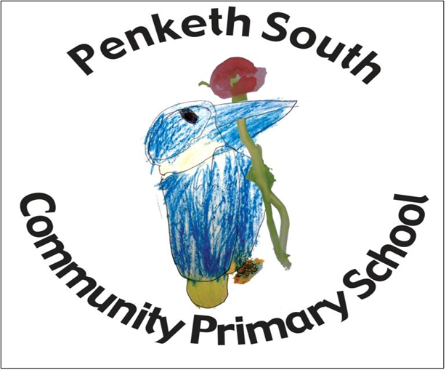

“Purpose of study
Learning a foreign language is a liberation from insularity and provides an opening to other cultures. A high-quality languages education should foster pupils’ curiosity and deepen their understanding of the world. The teaching should enable pupils to express their ideas and thoughts in another language and to understand and respond to its speakers, both in speech and in writing. It should also provide opportunities for them to communicate for practical purposes, learn new ways of thinking and read great literature in the original language. Language teaching should provide the foundation for learning further languages, equipping pupils to study and work in other countries.”
-The National Curriculum in England: Key stages 1 and 2 Framework Document. September 2013
Context:
The KS2 classes have been language learners. The school is a one form entry school with approximately 90 pupils across KS2. The first language of the majority of pupils in the school is English. There are also a number of pupils who have Cantonese as their first language.

Intent
The intent of our Languages curriculum is to inspire, nurture an appreciation of languages and fire an enthusiasm about learning a language. We want our children to grow in an appreciation of other cultures, customs and ways of life. At Penketh South Primary School, German is delivered by the class teachers, supported by the Primary Languages Network Scheme of Work. Lesson content is mapped progressively within four key areas of language; speaking, listening, reading and writing. Key Stage 1 is our introduction to languages. Although non-statutory, at Penketh South CP School we believe it allows our children to have a great starting point in learning a language and provides our children with the opportunity for pre learning in the areas of speaking and listening. From Year 3, reading and writing are embedded alongside speaking and listening to be taught progressively throughout Key Stage 2. In order to become articulate learners, children are provided with the opportunity to learn new vocabulary and phrases and to use their knowledge to take part in conversation with their peers. We will provide opportunities for our children to develop as independent, confident and successful learners who have high aspirations for the future.
Implementation
Children in KS2 learn German. We have recently moved from a 2 – year programme of learning German in Year 3 and 4 and French in Year 5 and 6 to learning German across all four-year groups. This enables the learner to build on the success on previous years and show their progression skills and knowledge.
In KS2 children are taught by their class teacher for 30 minutes per week and school aims to follow up activities when appropriate outside of the language lesson. Teachers are supported by a native speaker e.g. team teaching of lessons. Teachers follow the Scheme of Works set out by Primary Languages Network. These follow the same structure and content for non-native speakers, therefore providing support for non – native speakers.

The subject is managed by the Languages Co-ordinator. To ensure the language skills of staff are developed and sustained the school are members of the Primary Languages Network. This provides all the materials, resources and support sound files and activities to enable the school to ensure progression in language learning across the four core skills and also the DfE 12 Attainment Targets. The co-ordinator will advise, work with and guide staff and the visiting specialist teacher when required.
Our school follows the Primary Languages Network scheme of work but it is adapted to fit within our context and our pupils. It is a live scheme which is continually updated and revised in order to meet with current curriculum standards. Alongside the planning provided, the network also enriches this through accompanying power points, pod casts (spoken by native speakers) links to authentic literature, songs, games, culture points of reference, links to appropriate websites. The school is committed to ensuring pupils of all backgrounds and abilities can access the languages curriculum. The subject leader will review the content of the curriculum and any relevant assessment or teaching practices, and make sure any necessary reasonable adjustments are arranged so all pupils can access the school’s languages curriculum.
To promote an active learning of languages a range of teaching methods are implemented to ensure that the children are developing their linguistic skills through listening, speaking, reading and writing in order to be secondary ready. Activities can consist of actions, rhymes, stories, song, drama, grammar focus, video clips, air writing, sentence structure, dictionary work, book making and many more creative ways to extend, embed and combine language skills.
Impact
Currently, our assessment is formative across the four language skills and the progress made in these throughout KS2. Our German curriculum is planned to demonstrate progression and to ensure that the children make progress in this subject. This is done informally during the lessons in order to evaluate what the children have learned and inform the teacher about the next steps in their language planning. Assessment during the lessons is split into key areas; Listening and responding; Speaking; Reading and Responding and Writing. Through monitoring, we will measure the impact of the subject through: Pupil Voice, Book Scrutiny, Lesson observations which highlight strengths and achievement and any improvements in knowledge and skills that still need to be embedded.. Class Teachers collate images and videos of children’s learning and include these on their SWAYs, regular dialogue with colleagues is held to share good practice and reports of the standards in German are being reported to SLT and Governors.
Reviewed September 2022
Janou Birchall

